# Methodology

As it was explained in chapter 2, the transitory frequency response of the system and therefore its stable and reliable operation after a perturbation, depends on the inherent characteristics of the power system (system inertia) and the counteraction measurements engaged automatically by the system (primary reserve). As the share of inverter based generation increases the more prompt to instability the power system becomes. In this sense the added IBFPR must be capable of maintaining transitory frequency value within the allowed limits.

Two terms commonly found in the literature of power system stability will be used along this section:

* Inertia constant H: It has units of seconds (s) and it is the ratio of the kinetic energy stored in the rotating masses of the generators (MWs) and its nominal capacity (MVA).
* Acceleration time constant Ta: It also has the units of seconds (s) but this is the ratio of double the kinetic energy (MWs) and generators nominal power output (MW).

Swinging equation can be expressed as follows:

**Equation 3‑1**

To describe the penetration of inverter based generation into the grid, these terms can be related to the overall power system. Even though the inertia constant is most commonly used in the literature, the term of system acceleration constant is used instead when the penetration of non-synchronous generation in a power system is evaluated (ENTSOE 2016); this due to the fact it relates the load real power term (MW).

In this section the steps and methods applied in order to calculate the required Inverter Based Fast Power Reserve (IBFPR) to maintain frequency stability are presented.

## Determination of IBFPR

Figure 3-1 depicts the typical frequency response when a negative power unbalance occurs in a power system. If the unbalance is high enough or the system inertia is too low, the initial ROCOF (XXX Maximum at beginning foot note) can lead to frequency excursions below the UFLS value. The value of ROCOF is brought to zero normally by the action of the primary reserve; equalizing the power unbalance assuming no load frequency dependency. At this time the Nadir frequency is reached as well.

When it is assumed that no load is rejected at UFLS, the frequency continues dropping below 49 Hz. The time at which the system frequency equals the UFLS value is called in this thesis as critical time. This is the maximum available time for the Inverter based reserve to deploy the required power to the system.

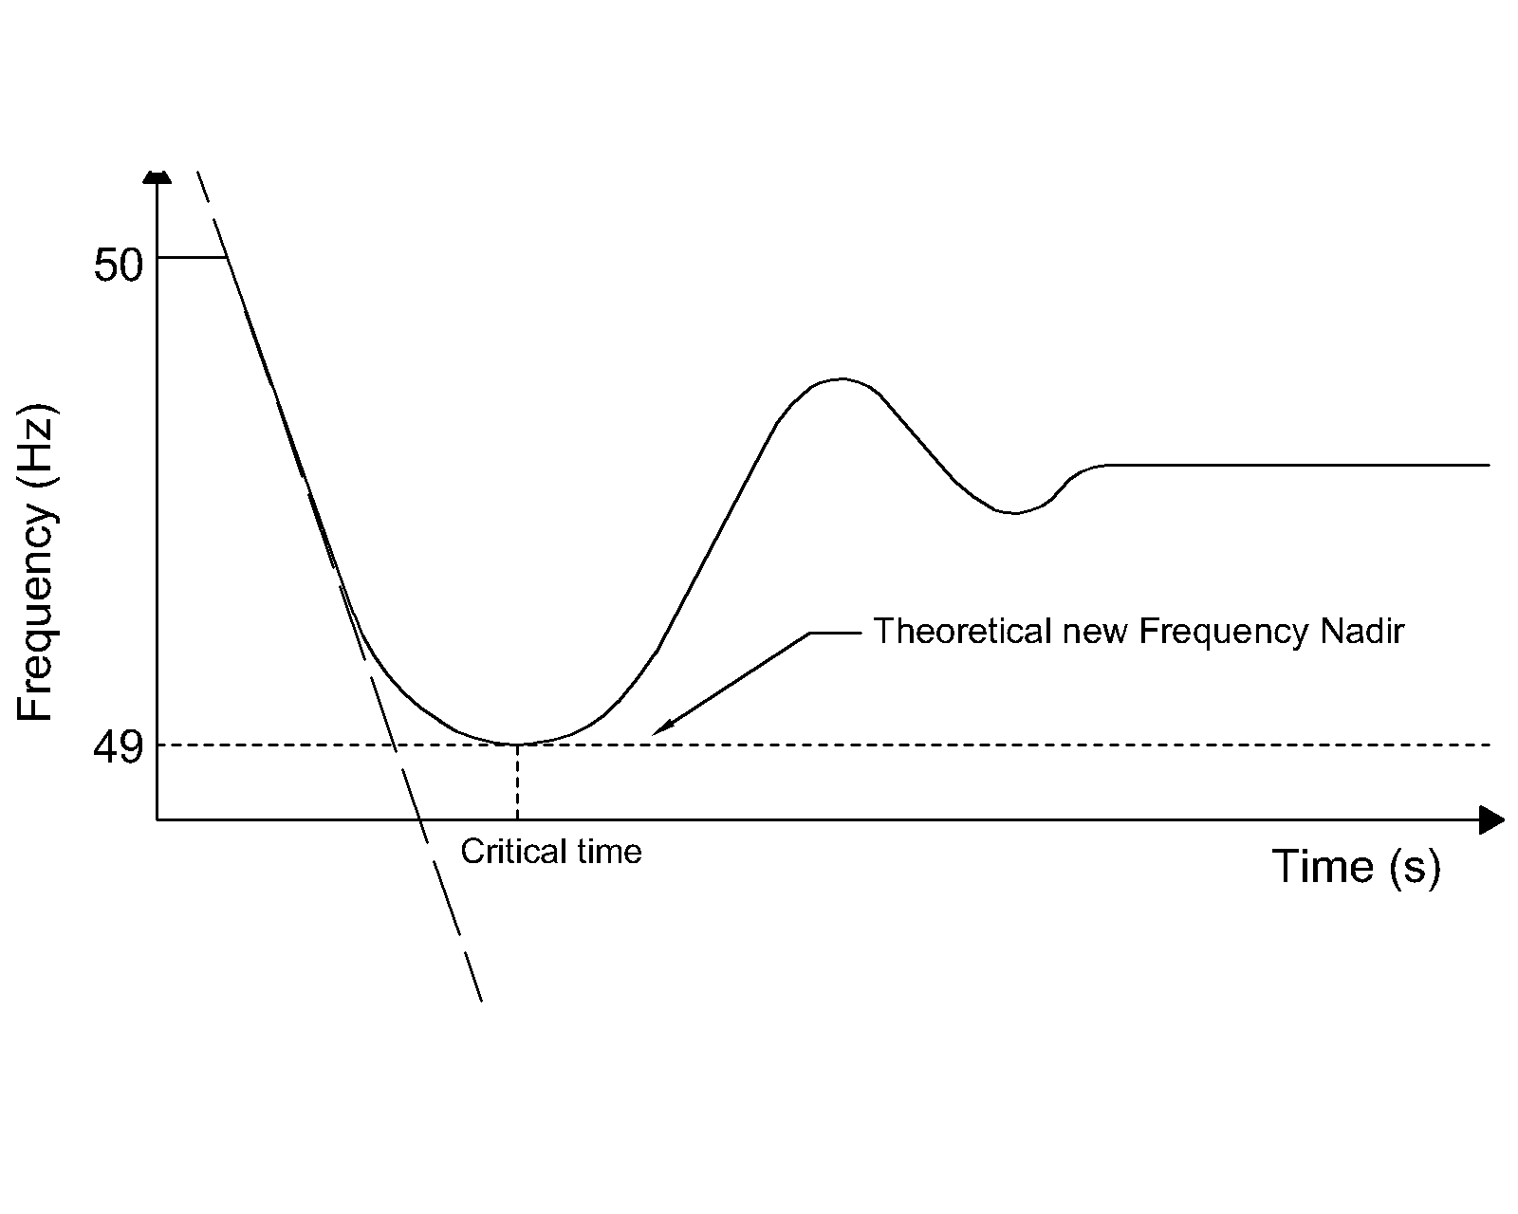

**Figure 3‑2: Expected power systeem frequency response with the addition of Inverter Based Fast Power Reserve.**

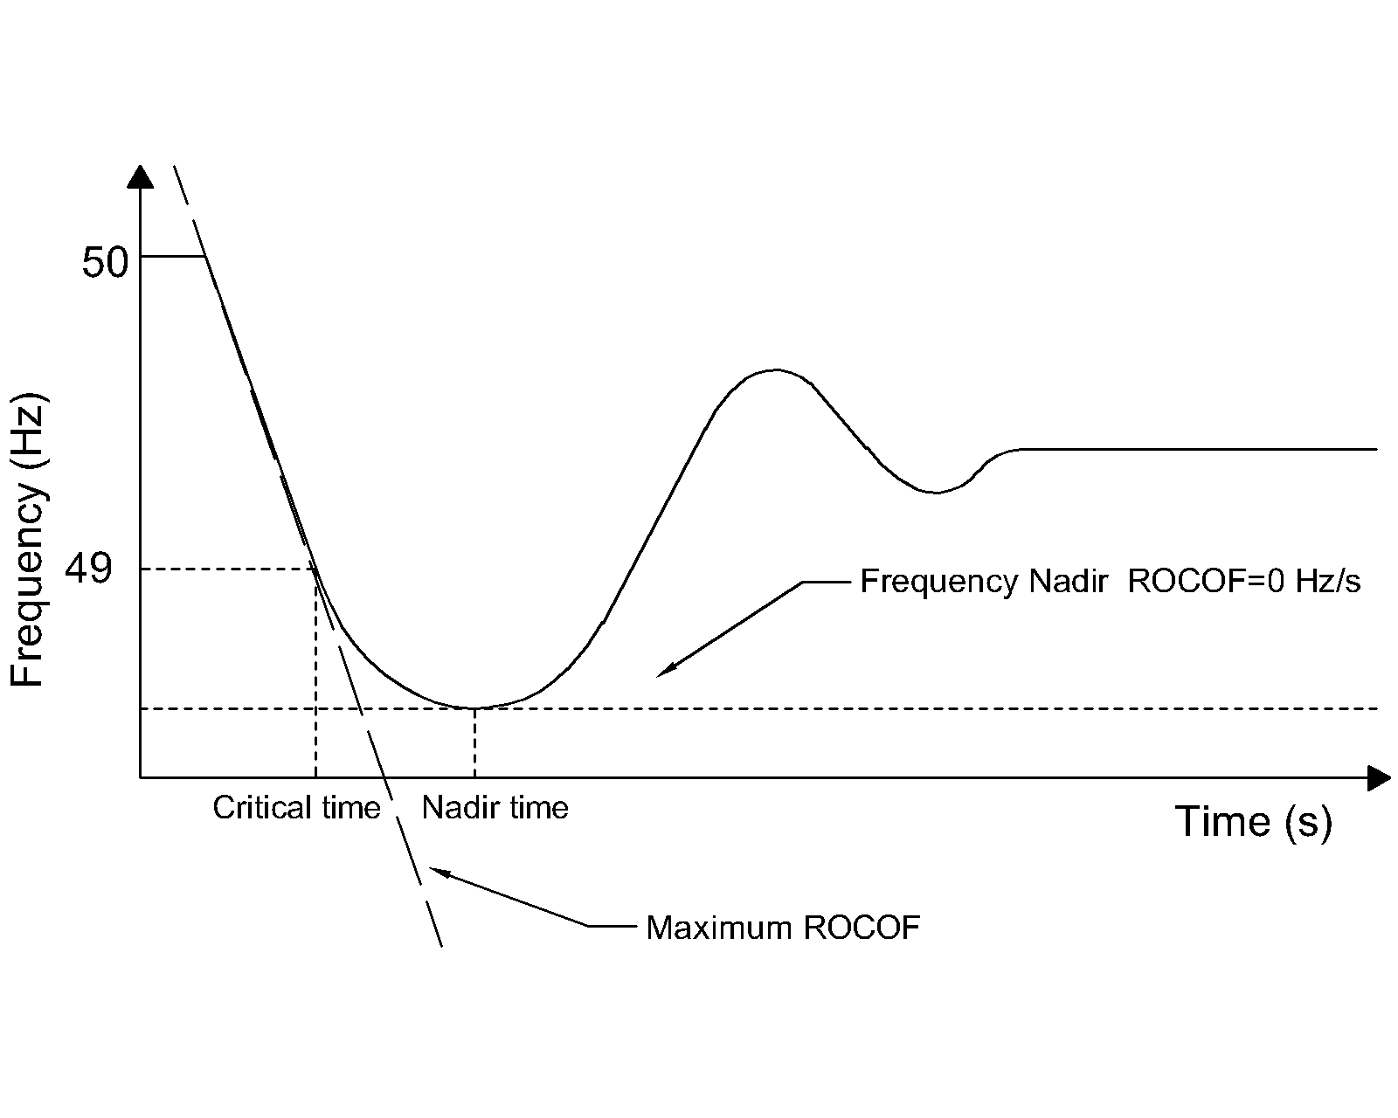

**Figure 3‑1: Frequency response of a typical power system subjected to a severe negative power unbalace.**

In the critical condition that would lead to load shedding, it is expected from the IBFPR to at least counteract the ROCOF at the critical time, as illustrated in figure 3-2.

Recalling equation 3-1; it is necessary that the machines accelerating power (power unbalance) become zero at the critical time.

**Equation 3‑2**

Where *Pa* is accelerating power, *Pmech* is mechanical power, *Pelec* is electrical (load) power, *tcr* is the critical time and *PIBFPR* is inverter based fast power reserve.

Typical primary power reserve response follows the indicated behavior shown in figure 3-4. Conventional turbine governor response is frequency dependent and may not respond linearly. For the estimation of IBFPR it was assumed a linear power deployment over time. Inspecting equation 3-1; it can be notice that only the power unbalance determines the rate of change in frequency in the system along with the kinetic energy stored in the rotating masses of the generators. For this reason the analysis is focused on the change on mechanical power after the event, ignoring the electrical load and mechanical power in the stable operation before the perturbation.

From the assumption of a linear mechanical deployment given from the synchronous machines governors, the change in mechanical power, after a power unbalance ΔP, is given by *ΔP/tnadir*, where *tnadir* represents the time at which the nadir frequency occurs. Given the power balance equation 3-2 at the critical time, *tcr*; The IBFPR response must be equal to *Pelec-Pmech*, being *Pelec* equal to *ΔP*.

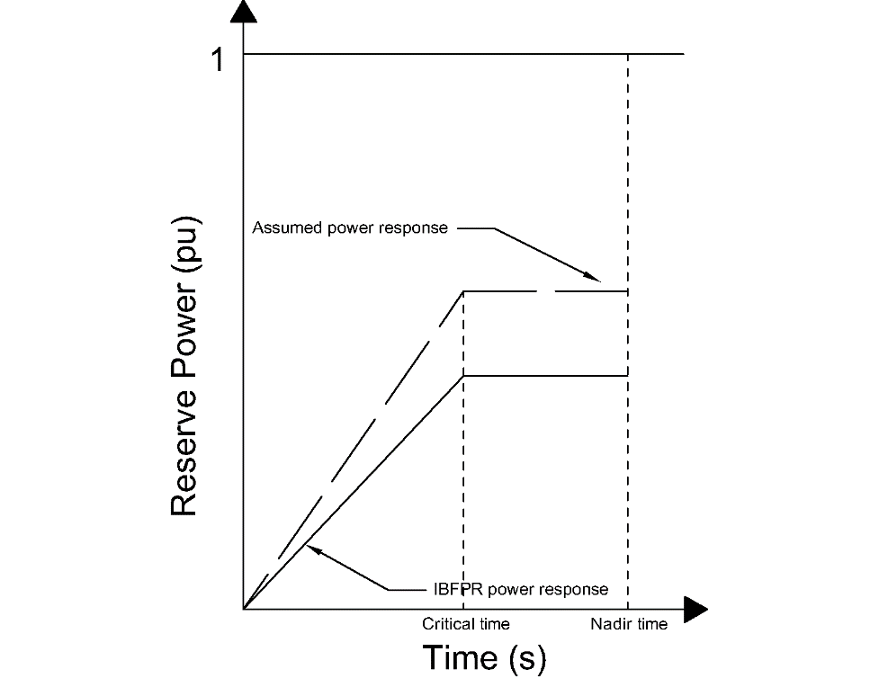

**Figure 3‑3: Assumed primary power reserve and IBFPR.**

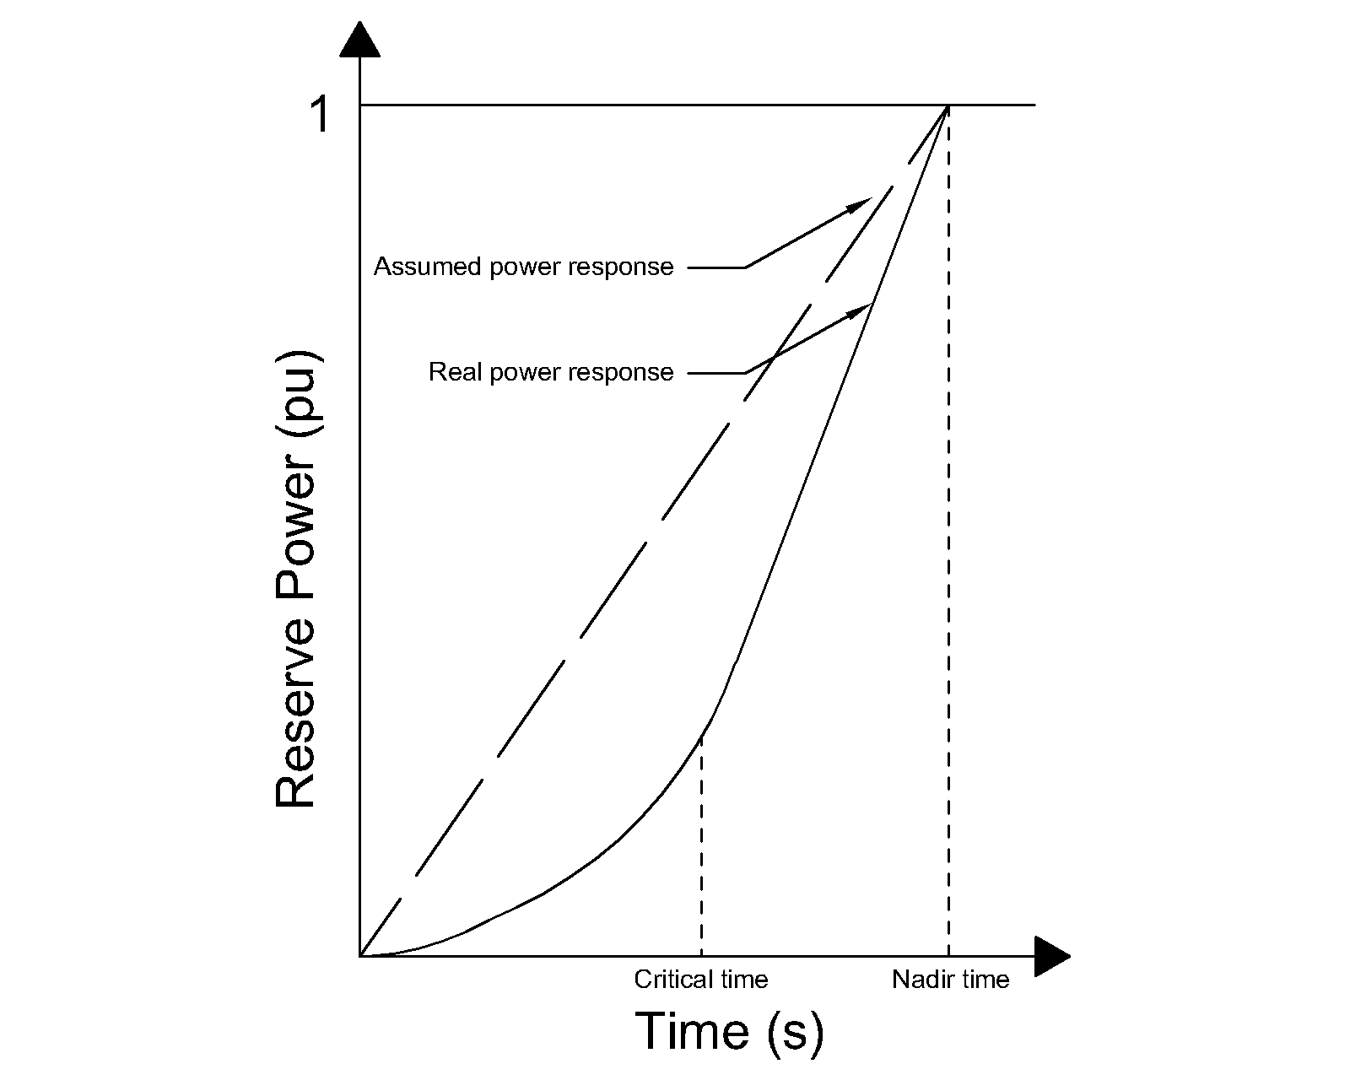

**Figure 3‑4: Comparisson of assumed power reserve deployment and typical real response.**

Substituting *Pmech* by *ΔP/tnadir* and *Pelec* by *ΔP* in equation 3-2, the following expression is obtained for the PIBFPR at time *tcr*.

**Equation 3‑3**

It is assumed that PIBFPR remains with a constant power output after *tcr* long enough to stabilize the system frequency. The result of the previous equation represents the slope of the power output since the inception of the incident until the critical time, which with the implementation of IBFPR, it will be not any longer critical but rather it will be the new desired nadir frequency time.

**Equation 3‑4: IBFPR before critical time.**

According to the obtained expression; it can be realized that the desired power response from the inverters depends exclusively on parameters which cannot be directly measured from the grid connection point. In a real situation the values of *ΔP*, *tnadir* and *tcr* cannot be known in advance, representing this factors a challenge in the implementation of this ideal power response. Those values are dependent on the grid characteristic; depending on the primary conventional reserve deployment time and the overall system inertia. Thus two main cases were considered for the remaining analysis with the intent of covering a wider range of systems with different characteristics.

## Cases for Assessing IBFPR

As presented in the previous section, the values of critical time and nadir frequency time depend on the system unbalance and primary reserve deployment time. In chapter 2 it was illustrated the different governor response for different primary reserve type. To be able to assess the influence of the grid size and the primary reserve characteristics, two main cases were considered.

* Micro-grid Case: For the evaluation of this case typical governor data is considered in a well-known and studied benchmark grid topology as the WSCC model, also known as the IEEE 9 bus model.
* European scale Case: In the European scale, all synchronous machines are modeled and simplified as one single machine, provided with the characteristic expected from the overall system.

### Micro-grid Case-IEEE 9 bus model

For the study of power systems and the increasing interest in stability analysis in microgrids, the IEEE benchmarks represent a widely used option, based on some real data; this is also the case of the IEEE 9 bus model or WSCC (Western System Coordinated Council). The IEEE 9 bus model is a representation of the western interconnected power system of North America. For stability and reliability studies, this system has been employed in many publications as study case (Atieh Delavari et al.), which allows the comparison of results. Figure 3-5 illustrates grid’s configuration. Detailed grid parameters are found in Appendix XXX ref

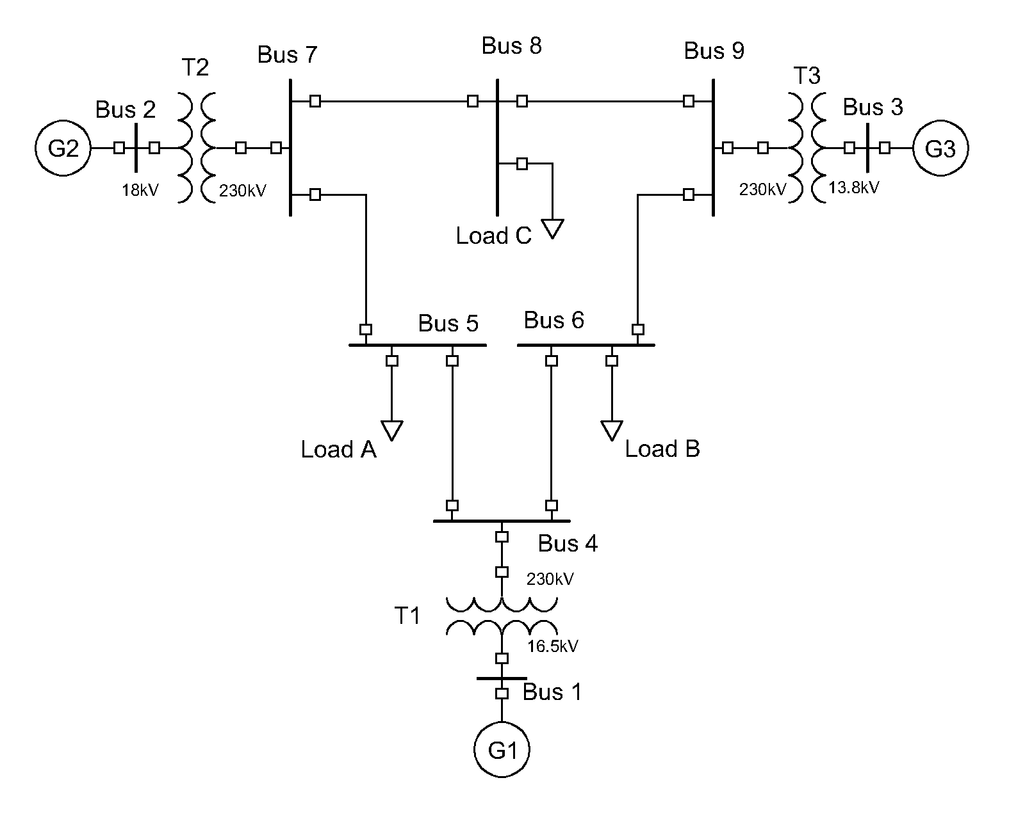

**Figure 3‑5: WSCC or IEEE 9 bus model used for stability studies.**

|  |  |
| --- | --- |
|  | Quantity |
| Buses | 9 |
| Transformers | 3 |
| Transmission lines | 6 |
| Generators | 3 |
| Load | 3 (315MW total) |

As a first step to evaluate the impact of inverter based generation and power unbalances in the grid, the whole system is simplified as one single generating unit; neglecting all losses in the system (Transformers, transmission lines and generators) with the assumption that the mechanical output of the governor is the same than the electrical power output at generator terminals. A schematic representation of such system is presented in figure 3-6.

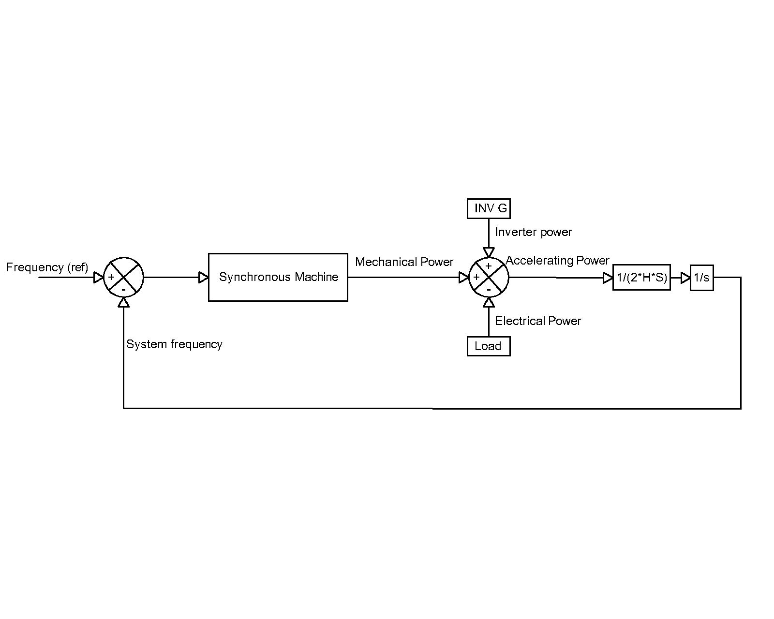

**Figure 3‑6: Single machine representation of the IEEE 9 bus model.**

The governor model presented figure 3-7 is used to represent the simplified synchronous machine. Although there are plenty of options for governor modelling; the selection of such model was based on the availability of the typical time constants according to generator capacity (Anderson and Fouad 2002). Additionally, depending on the selected parameters, the model can be used as steam or hydro governing system. The step response of the governor model under a three different penetration of non-synchronous generation is presented in figure 3-8. Typical time constants values are presented in APPEMDIX

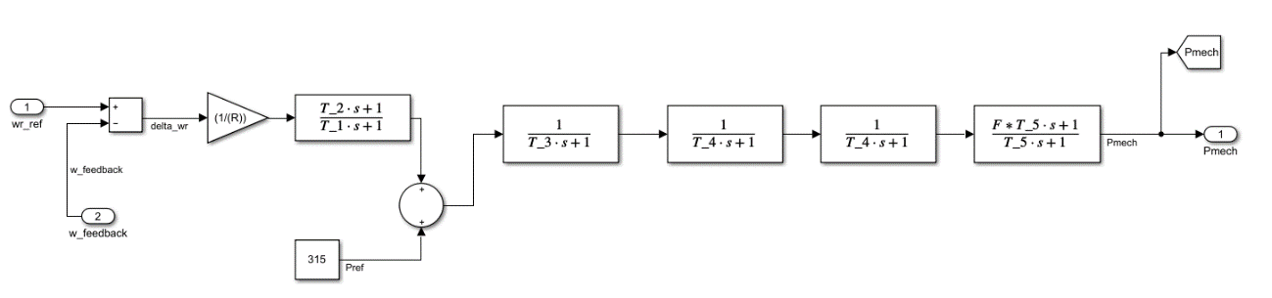

**Figure 3‑7: Governor representation implemented as synchronous response in the system. Where wrref is the nominal rotational mechanical speed in rad/s, wfeedback the measured mechanical speed in rad/s, Pref is the reference power in MW, R is the droop characteristic in pu and Pmech is the mechanical power output of the synchronous machine in MW.**

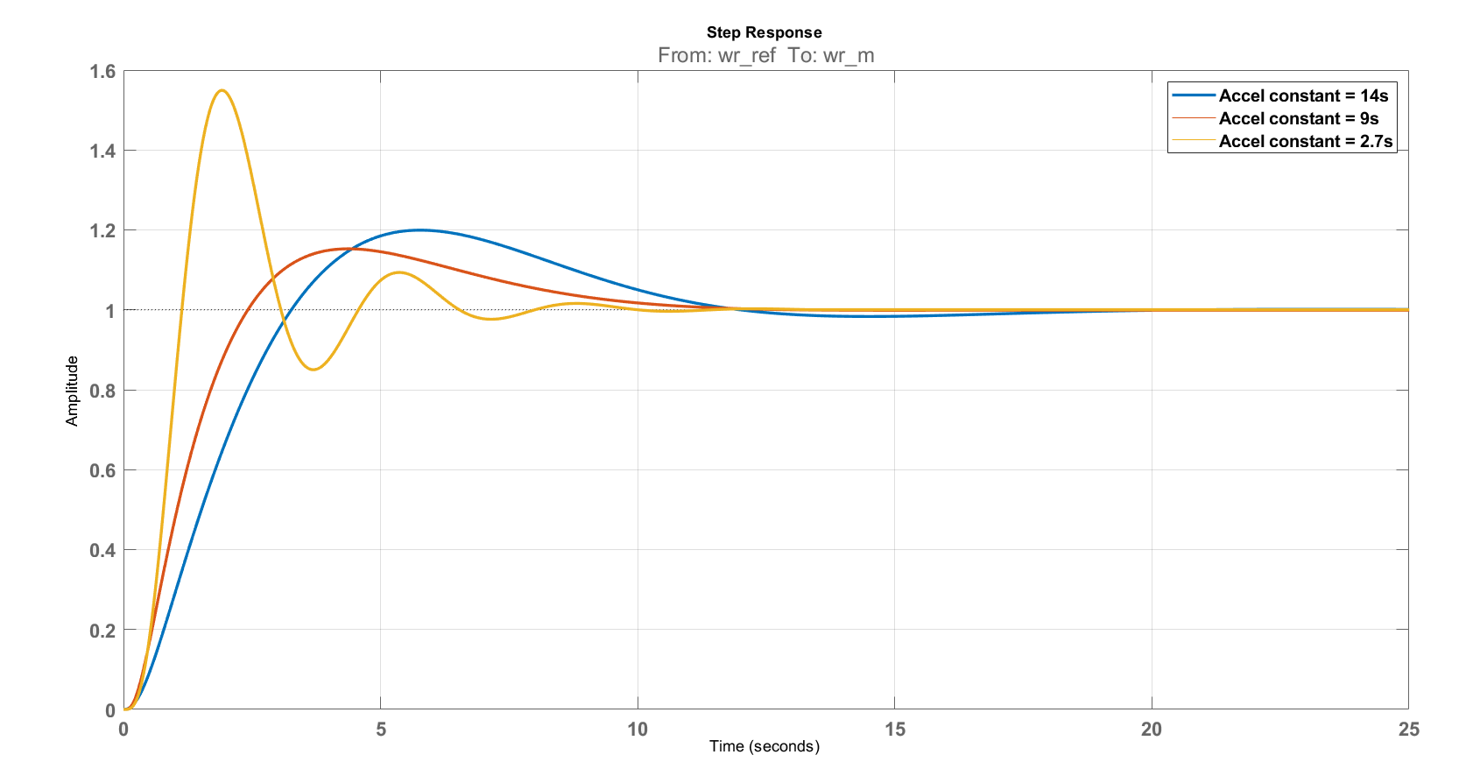

**Figure 3‑8: Step response of Governor model for different values of acceleration time constant.**

For the sake of simplicity, the values of kinetic energy and time constants of the synchronous machines of 835 MVA were selected to represent the synchronous response, with the load of 315 MW the system acceleration constant is 14 s (ref), which is approximately today’s Europe acceleration constant (ENTSOE 2016). This is the base scenario, assuming 100% synchronous generation. To evaluate the impact of the penetration of inverter based generation; the values of lower capacity generators were selected (ref), assuming the compensation of the remaining power by a constant power source representing the inverter based generation, decreasing in this manner the total system acceleration constant thus the kinetic energy of the generator. Up to this point, neither synthetic inertia nor frequency support from renewables is considered. Inverter based power output remains constant before, during and after the perturbation. Therefore the system unbalance is covered only by the synchronous equivalent machine.

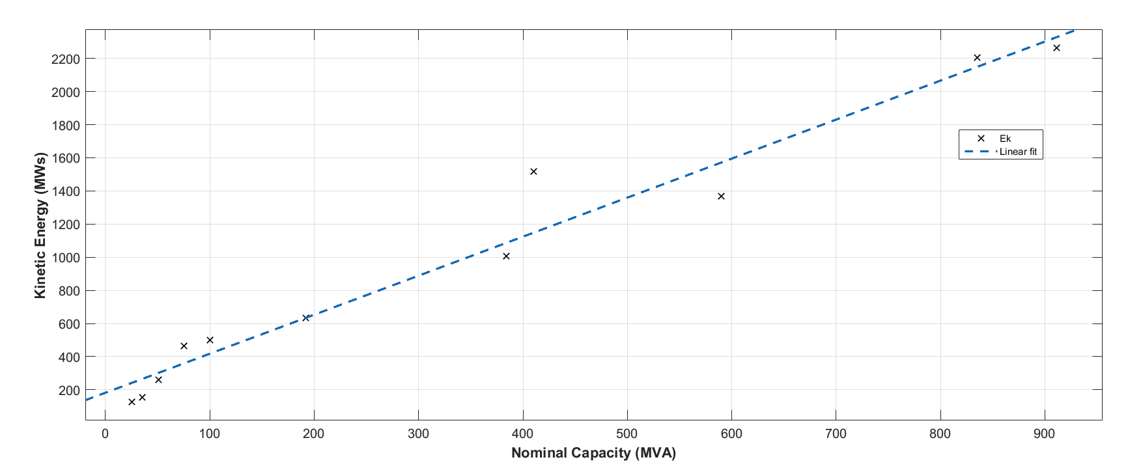

**Figure 3‑9: Kinetic energy stored in generator rotating masses as function of generator capacity.**

Even though unbalances up to 40% were simulated in each inertia scenario, the power capacity limit of the generators was disregarded for estimation of the critical time. The negative unbalance was simulated by increasing the system load by the corresponding factor. A block diagram representing the system in the given conditions was designed in MATLAB-SIMULINK. With the help of a MATLAB code several simulations were run and the critical and nadir times acquired for each scenario. With the calculated times, the IBFPR to avoid load shedding under each scenario was calculated as given by equation XXX and it is shown in the Results section.

All the acquired values of critical time, as result from the simulations, are then related with the system ROCOF, so a regression can be performed and link the critical time with system ROCOF.

For the system conditions and the employment of the fitting tool provided by MATLAB, the following expression is obtained for critical time as a function of ROCOF:

**Equation 3‑5**

As it will be detailed shown in the result section, for unstable conditions the maximum critical time is 2.0322s 2.2685s. Therefore critical time must be lower or equal to that value; calculating in this way that the minimum ROCOF for activation as 0.6741Hz/s.

**Implementation of IBFPR in the IEEE 9 bus model**

In order to test the values found of power response from the inverters, these are implemented through a simple SIMULINK algorithm which estimates the power unbalance and critical time based on the measurement of the ROCOF, when system inertia it is known. Based on those estimated values, the algorithm provides the power ramp before the calculated critical time is reached and maintain constant power output after this time.

The algorithm works in a simple way:

1. It measures the system ROCOF
2. If the value exceeds 0.674 Hz/s the IBFPR is activated
3. According to the measured value of ROCOF and available system inertia, a ramp power response is injected into the system during a time equal to the calculated critical time according to equation 3-4.
4. When the calculated critical time is reached, the IBFPR must stop ramping power and keep a steady value until frequency is restore to an acceptable value as per equation 3-3.

The block diagram is provided in Appendix XXXX

**Synthetic Inertia in the IEEE 9 bus model**

Synthetic inertia was explained in chapter 2 as one of the new techniques that manufactures and researchers are considering to tackle with the low inertia problem in power systems (General Electric International 2013) (Dreidy et al. 2017). Frequency support through synthetic inertia was considered with the following assumptions (Dreidy et al. 2017):

1. Power output from synthetic inertia is limited to 10% of wind turbine nominal power.
2. Due to mechanical and thermal stresses, the additional power can be delivered only for a maximum time of 10s.
3. It’s assumed that all wind turbines operate at its maximum power output. The value of 1.5 MW was selected for such purpose.
4. In order to avoid wind turbine stall, the removed kinetic energy from the blades (injected to the grid in electrical form) it is limited to half (E. Muljadi, V. Gevorgian, and M. Singh: NREL and S. Santoso: University of Texas - Austin 2012).

To be able to extract energy from the rotating blades of the wind turbine, an adequate control system is needed. From the expression of power as the derivative of energy and the kinetic energy stored in the blades, the rate of energy extracted from the wind turbine can be obtained, considering that rotational speed changes in time.

; ;

**Equation 3‑6**

Where *Ek* is kinetic energy, *Hwt* is the turbine inertia constant, *w* the rotational speed and *Jwt* the turbine inertia.

Equation 3-6 represents the rate of change of kinetic energy extracted from the rotating masses of the wind turbine in pu. The implementation of such equation in SIMULINK is shown in figure 3-10. Additionally, a gain block *Ki* was added in order to inject more power from the very beginning of the power unbalance. A filter at the signal entrance was added in order to suppress non desired oscillations on the system (General Electric International 2013).

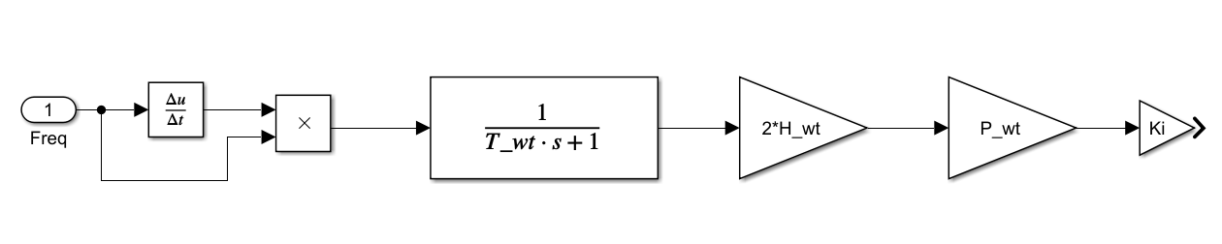

**Figure 3‑10: Synthetic inertia control model where Twt is the filter constant, Hwt is the turbine’s inertia constant, Pwt is the nominal wind capacity (MW) and Ki is a gain constant. Frequency input in pu and system output is power in MW.**

Typical values for inertia constant of wind turbines are not openly available from the manufacturers to the public. Hence an approximate value was calculated with the utilization of an equation which relates nominal power and inertia constant for wind turbines (González Rodríguez et al. 2007).

**Equation 3‑7: Wind turbine inertia constant as function of the nominal power in MW.**

For a wind turbine with nominal power output of 1.5 MW the value of *H* corresponds to 4.37s, which is in an acceptable range (Wu and Infield 2013).

It is assumed that all the wind turbines, when operating, are delivering their nominal power output. A nominal rotational speed of 18rev/min was considered (Wu and Infield 2013). To avoid the wind turbine to stall, only a reduction of 5rev/min it is allowed by the implementation of the control system. This change of rotational speed equals a change of 3 MWs reduction on kinetic energy out of a total of 6 MWs.

|  |  |  |  |
| --- | --- | --- | --- |
| Twt (-) | Hwt (s) | Pwt (MW) | Ki (-) |
| 1 | 4.37 | 1.5*nwt 1 | 10 |

**Synthetic Inertia and IBFPR in the IEEE 9 bus model**

In this model the contribution to system frequency stability of both models operating together is evaluated as shown in figure 3-11. No additional modification or adjustment was performed to the IBFPR or the synthetic inertia model.

Procuring to simulate more real conditions, an intentional delay was introduced to the IBPR and the SI response. This was done with the intention of emulate the delay related with frequency measurement, filtering and signal processing. A delay transport block was added in the power response. Depending on the technique and precision desired, the time for acquiring frequency reading may differ considerably, however, for the purpose of this research the time of 100 ms with an error of 5 mHz was taken for calculations. ref

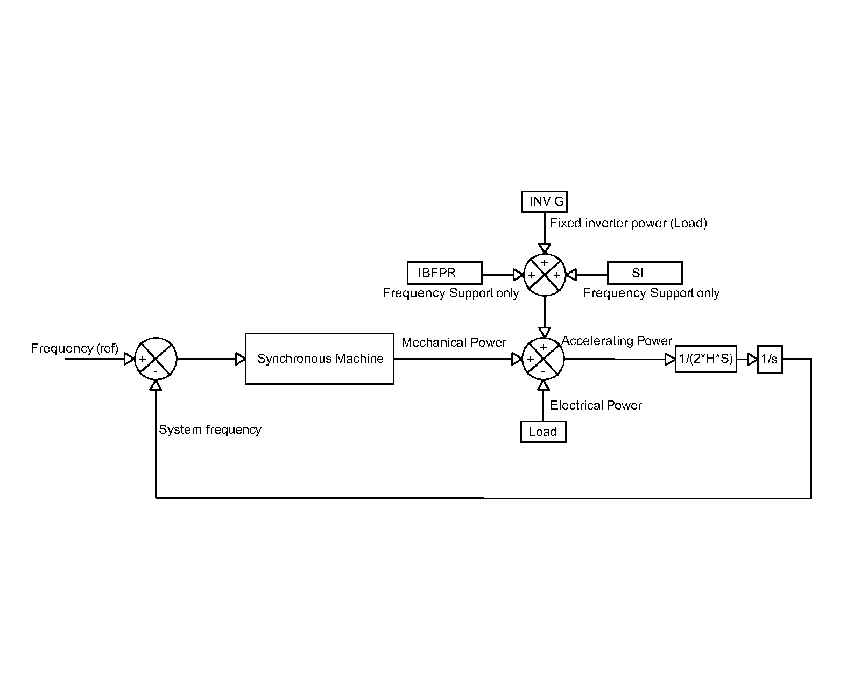

**Figure 3‑11: Synthetic inertia and IBFPR implementation.**

**Analysis of the insertion of multiple machines in the simulation**

It was previously stated that in the first approach, only the total load was considered in the simulations as well as the synchronous generation represented by one single machine and no system losses. Since it is desired to compare the results of the system with such simplifications against some model that takes into account the whole system components, losses and dynamics; A SIMSCAPE-SIMULINK representation of the IEEE 9 bus model was implemented (Atieh Delavari et al.). In this representation, simulations for different values of system inertia and load unbalance were performed, similarly as it was done with the simplified block representation of the model.

In order to evaluate the validity of the equation describing the IBFPR needed to avoid ULFS, the SIMSCAPE model was modified with the insertion of ideal controlled power sources blocks, which were set up to inject power into the grid accordingly to the simulated scenario. Therefore, no means of frequency measurement were included and only IBFPR was assessed.

**System settings for stability study.**

Since it is desired to compared the complete representation of the IEEE 9 bus model against the simplified model representation; it is assumed in the same manner that the total acceleration time constant of the system equals 14s, similarly as in the block representation. Hence the same kinetic energy should be distributed among the three generator’s rotating masses in the SIMSCAPE model as in the simplified representation. From equation 3-8 for system acceleration time constant, it can be easily calculated that the system kinetic energy with 14 s (100% synchronous generation) is 2205 MWs.

**Equation 3‑8**

Due to the fact that inverter based generation reduces the system kinetic energy; for different levels of inverter based generation, the generators nominal capacities (*S*, MVA) values were kept constant and the inertia constant (*H*, s) of each machine multiplied by the synchronous share factor (*fss*). Total system kinetic energy is the summation of all units together. In this way, the synchronous generators in the initial state of equilibrium represent both power sources, inverter based plus synchronous.

**Equation 3‑9**

**Prime mover and governor**

The type of prime mover selected was conventional steam turbines and its governor system. Steam governor and turbine representation in SIMSCAPE block is presented in figure 3-12

The block contains a complete tandem-compound steam prime mover, including a speed governing system, a four-stage steam turbine, and a shaft with up to four masses. The speed governing system consists of a proportional regulator, a speed relay, and a servomotor controlling the gate opening. The steam turbine has four stages, each modeled by a first-order transfer function. The first stage represents the steam chest while the three other stages represent either reheaters or crossover piping. The boiler is not modeled and boiler pressure is constant at 1.0 pu. Additionally, an exciter system was added to the machines, the parameters of such blocks are presented in APPENDIX

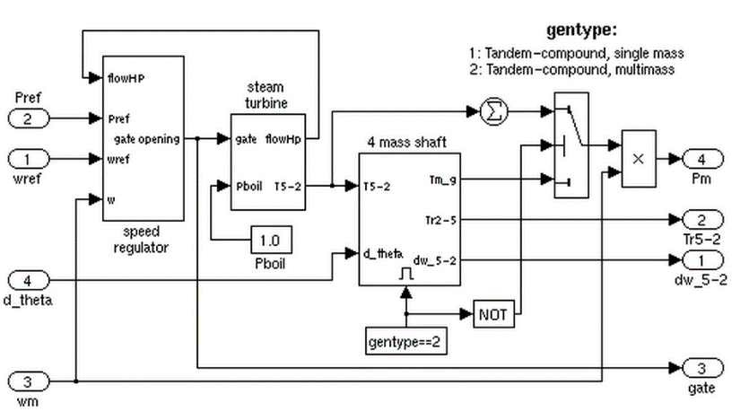

**Figure 3‑12: Governor and steam turbine model from SIMSCAPE library**

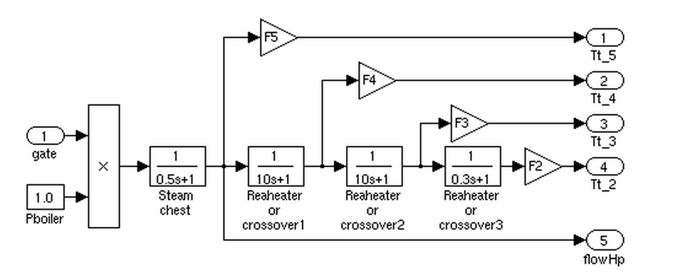

**Figure 3‑13: Steam turbine model**

In order to start the simulations in steady state, a load flow calculation of grid must be carried out with the objective of calculate the initial conditions for the exciter and prime mover models. Table XXX summarizes the main values for setting system initial conditions; acquired from the power flow tool provided by SIMSCAPE.

|  |  |  |  |  |
| --- | --- | --- | --- | --- |
| Bus number | Bus type | Voltage | Power | Reactive Power |
| Per unit | MW | MVAr |
| 1 | Slack | 1.04 ∠0° | 72.2 | 25.64 |
| 2 | PV | 1.025 ∠9.83° | 163 | 8 |
| 3 | PV | 1.025 ∠4.63° | 85 | -9.41 |
| 5 | PQ | 0.9949 ∠-4.42° | 125 | 50 |
| 6 | PQ | 1.01211 ∠-4.16° | 90 | 30 |
| 8 | PQ | 1.0172 ∠0.17° | 100 | 35 |

**IBFPR representation**

Similarly as it was done in the simplified block model, a subsystem is implemented along with the SIMSCAPE model in order to represent the IBFPR and analyze the system behavior with the addition of this power. To do so, the IBFPR was modeled as controlled current sources; such controlled sources will inject active power according to the load unbalance and system inertia simulated. Continuous voltage measurement is required in order to determine the amount of current needed to supply the requested power. Figure 3-14 depicts the schematics of the IBFPR control.

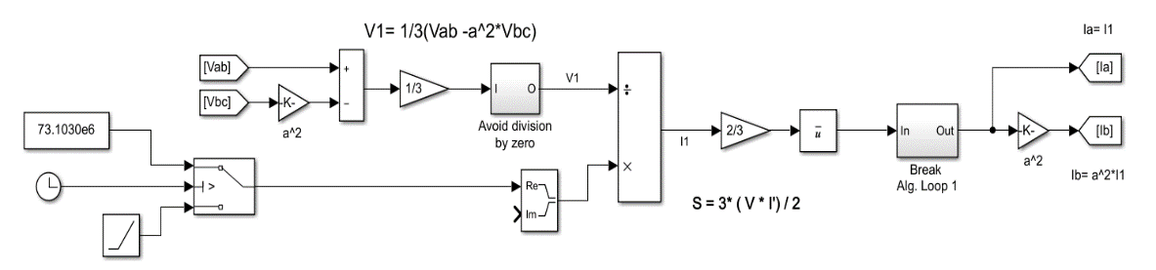

**Figure 3‑14:Model implemented to calculate the required current to meet the specified power rate.**

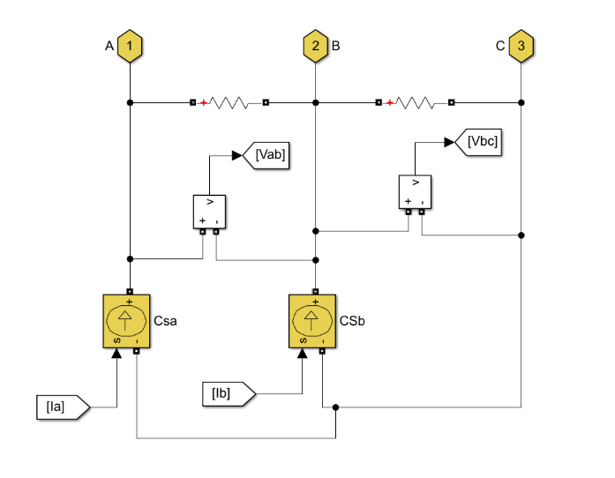

**Figure 3‑15: Controlled current sources acting as grid following inverters. Signals Ia and Ib comes from model in figure 3-14; similarly signals Vab and Vbc go to the same model.**

It can be noticed from figure 3-15 that the IBFPR is composed of 2 current sources, 2 voltage readers (complex measurement), two resistance and 3 connecting ports.

The IBFPR will have symmetrical and balanced characteristics. Due to this reason, the magnitude and angle of the current phasor will be obtained from the positive sequence of the measured voltage, since unsymmetrical line voltages may be present on the system.

Given a symmetrical IBFPR; only two current sources are need because the addition of balanced currents in a three phase system equals 0. Hence, leg c will be fed with the negative of the sum of both sources.

The ports are connected at the medium voltage side of the system (generator’s side). The resistance must have a high value (negligible current flowing through); this is a requirement for the implementation of SIMSCAPE current sources.

Figure 3-14 shows the block diagram implemented to obtain the positive symmetrical component of line voltage and the positive sequence of current that will be provided by the subsystem. From the definition of complex power and voltage symmetrical components in three phase systems, the positive sequence component of phase voltage and line current are obtained. The positive sequence component of complex power is equal to the complex balanced power (ref power system analysis):

**Equation 3‑10**

This equation is valid for RMS values of voltage and current; nevertheless the measured voltage values and the sought current values are given in peak values, the equation for power and current become:

**Equation 3‑11**

**Equation 3‑12**

With the help of the **a** operator (-0.5+j or 1∠120°) the values of the positive sequence component of phase voltage can be obtained.

From and

Since , and then after some algebraic manipulation the expression for becomes:

**Equation 3‑13**

With the obtained expressions for the positive sequence of phase voltage and complex power, the needed current to supply the IBFPR related to the measured voltages can be implemented. The ramping function will last until the critical time is reached, afterwards, the IBFPR output will remain constant.

**European Case**

Under normal operation ENTSOE has reported values of ROCOF in the range of 5-10 mHz/s for power outages of 1 GW in the current interconnected power system. If an unbalance event of more than 3 GW occurs with depleted primary reserve, extraordinary values of frequency and ROCOF might be reached. After serious disturbances the Continental European Power System has experienced ROCOF between 100 mHz/s and 1 Hz/s. Unbalances of 20% or more along with ROCOF greater than 1 Hz/s have been determined by experience to be critical (ENTSOE 2016).

ENTSOE has determined that under the case of the reference scenario (The loss of 3GW generation and 2%/Hz self-regulation) in the interconnected operation, the influence of inverter based generation, and therefore the reduction of system inertia would not jeopardize system stability. Due to the expected increase of non-synchronous generation in the future, international power trade and renewables variability; ENTSOE estates in its split reference scenario that the power system must be capable of withstanding unbalances greater than 40% with ROCOF of 2 Hz/s or higher. Under these circumstances the island must avoid load shedding. In this way two subcases are considered, one split scenario and the interconnected scenario.

To simulate the whole European power system a simplified approach was selected. Similarly as it was done with the simplified block model for the IEEE 9 bus model, in the equivalent European representation all the synchronous generation will be represented by a single machine, which will provide governor response when a perturbation takes place. Additional to the synchronous response, a load response of 2% was added to the model, which means that for every Hertz reduced or augmented, the load will reduce or increase by a 2%.

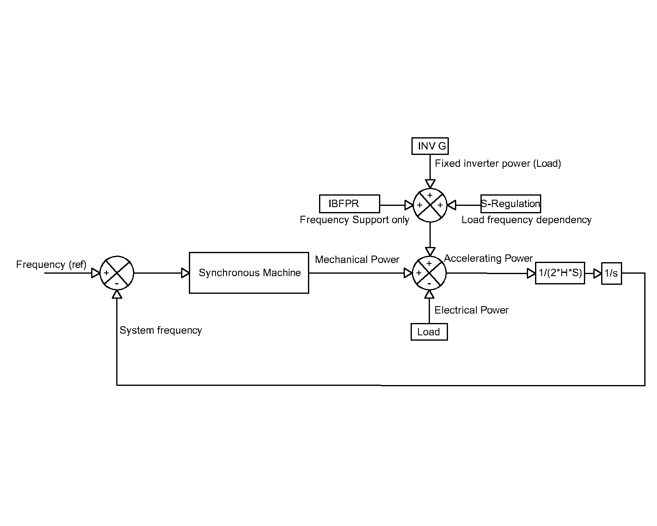

**Figure 3‑16: Simplified European power system.**

Figure 3-17 depicts the results of ENTSOE for the interconnected reference scenario for different system acceleration constants. It is intended that the implemented model performs in a similar way like the ENTSOE model for the given conditions.

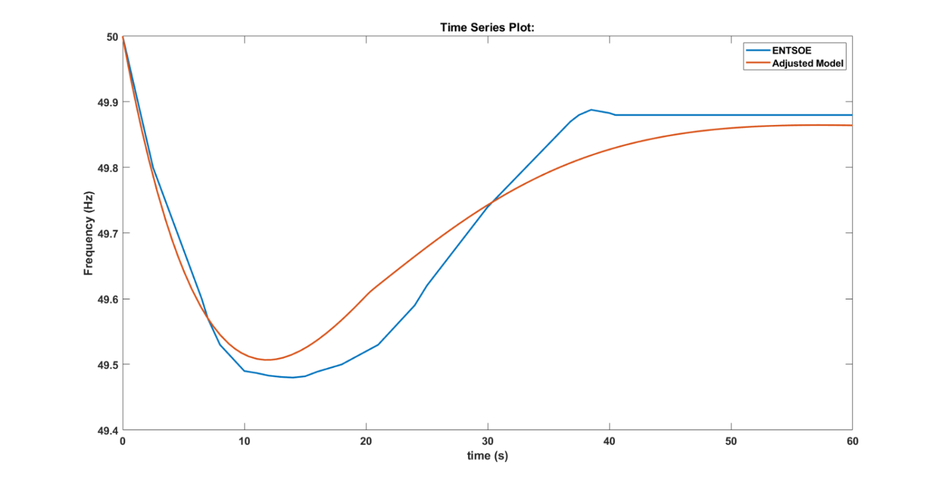

**Figure 3‑17: Comparisson between the modeled reference scenario by ENSOE and the adjusted model. Power loss of 3GW, load of 150 GW (2%), self-regulation of 2%/Hz and acceleration time constant of 10 s.**

To fit the behavior of the system to the modeled by ENTSOE, a PID controller was added in the SIMULINK microgrid model to the steam turbine governor; this was done with the intention of adjusting the time response of the primary reserve as much as possible to the desired one. With the PID approach, the primary power reserve can be easily adjusted with the assistance of the PID tuner app available in MATLAB. The period of time of utmost interest for analysis is from the inception of the power unbalance and the nadir time. Therefore, the system must perform as similar as possible in this region compared to the ENTSOE reference, whereas after the nadir time, the disparity between responses can be neglected. In the European scale the reserves must be completely deployed within 30s after the occurrence of the disturbance.

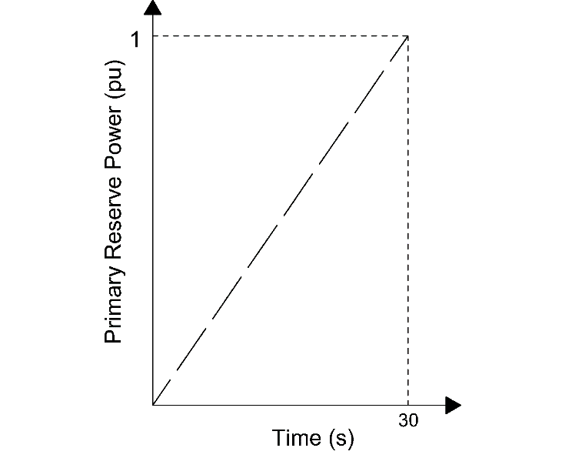

**Figure 3‑18: Primary reserve deployment time of the interconnected European system**

For the interconnected scenario is assumed that even in the presence of an extraordinary event the primary reserve would be deployed within 30 s. That does not ensure frequency stability and therefore the calculated IBFPR would be responsible of maintaining frequency stability. For each inertia scenario, the PID controller was modified in order to simulate the 30 s power deployment. In the split scenario the primary reserve deployment time was modified from 10 s until 30 s Ref XXX Turkey.

**System parameters**

A power system of *n* number of synchronous machines is assumed; having each of them a capacity *S* in MVA, a nominal power *Pn* in MW and a nominal power factor.

Assuming that each machine operates at a deloaded factor *dl* of *Pnom*; with an acceleration constant equal to *Tnom* then the number of machines *n*, for the synchronous load *Pload_sync* is:

**Equation 3‑14**

Then the time acceleration constant of the system Tsys can be obtained as follows:

**Equation 3‑15**

In this sense the base system time acceleration constant (synchronous share 100%) is calculated from the values of *Tnom*=10 s, *Sync_share*=1, and a deload factor *dl*=0.8 having as a result *Tsys*=12.5 s

Likewise it was presented in the former cases, in the European scale; the penetration of inverter based generation is assessed in the same way. In this case, the same levels of penetration as ENTSOE were evaluated. The values of the PID controller and the step response characteristics of the model are summarized in table XXX. For the interconnected case, unbalances up to 20% were simulated.

Although the load and therefore the size of the interconnected system and the resulting islands of the split scenarios may differ considerably. Due to the simplifications made in the model; both comprised by one single machine and one load using the swing equation, the representation of both models differs only in the PID controller which adjust the time response of the primary reserve.

Considering only the swing equation, as done in the model, it can be demonstrated that the ROCOF and therefore the frequency response of the system is only dependent on the percentage of load unbalance and the system acceleration time constant.

From the definition of ROCOF as and :

**Equation 3‑16**

In equation 3-16, the value of *∆Ppu* is the normalized value of power unbalance having as base power the value of load *PLOAD*. As shown in the equation, when only the swing equation is considered, the frequency response is only dependent on system acceleration constant and the relative value of unbalance. This relative value of unbalance varies during time depending on load response to change on frequency and the response of primary reserve of the system.

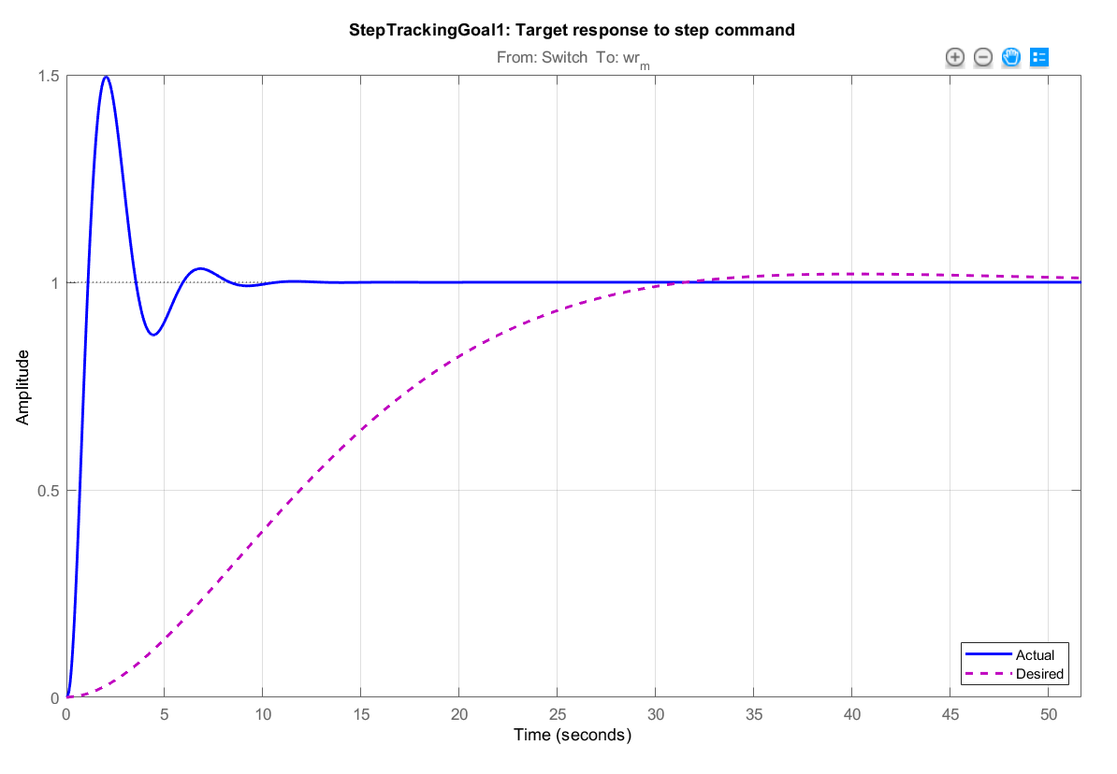

**Figure 3‑19: Comparisson between system step response before the PID tunning (blue) and the desired step response of the system (pink).**

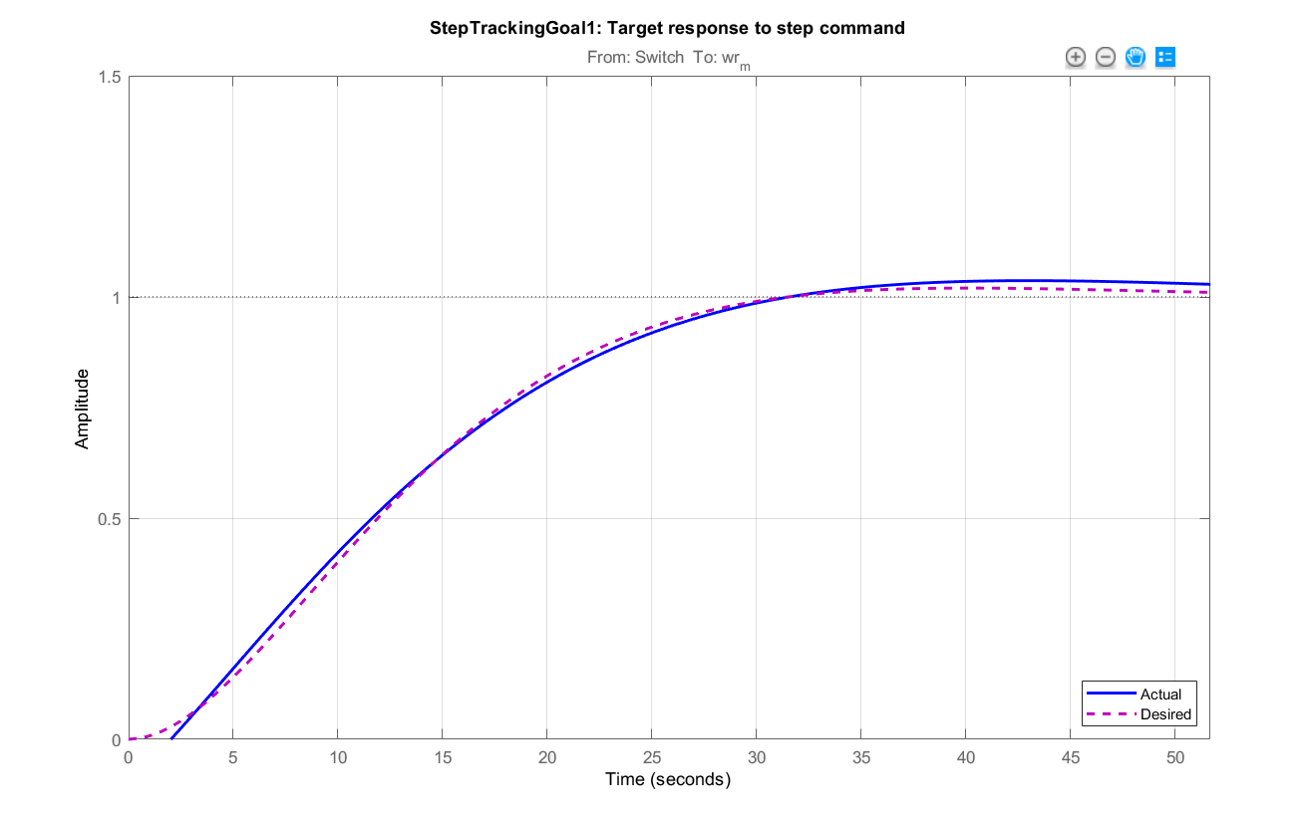

**Figure 3‑20: Comparisson between the actual response (blue) and the desired step response of the system (pink); after PID tunning.**

## Scenario Summary

**Micro-grid IEEE 9 bus model**

Case A: Simplified block model, one machine, one load and no losses.

* Determination of critical time
* Determination of IBFPR and impact of SI and frequency measurement delay

Case B: Multimachine system. Detailed model, every main component of the benchmark is considered.

* Determination of critical time
* Analysis of the Machines interaction with IBFPR model.
* Angle stability and modal analysis overview.

**European Scale**

Case A: Interconnected operation. Primary reserve deployment of 30s, power unbalance above reference scenario of ENTSOE

* Determination of critical time
* Determination of IBFPR and impact of SI and frequency measurement delay

Case B: Split operation. Analysis with unbalances up to 40% with variation of primary power reserve deployment between 10-30s

* Determination of critical time
* Determination of IBFPR and impact of SI and frequency measurement delay